How to access the 1000 Genomes data

Plink1.9

Download website：https://www.cog-genomics.org/plink/1.9/ 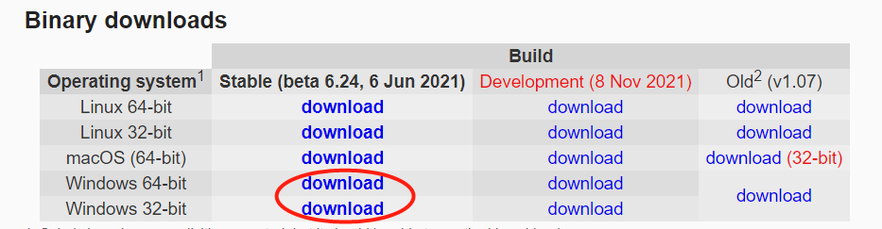

Plink2.0

Download website：https://www.cog-genomics.org/plink/2.0/ 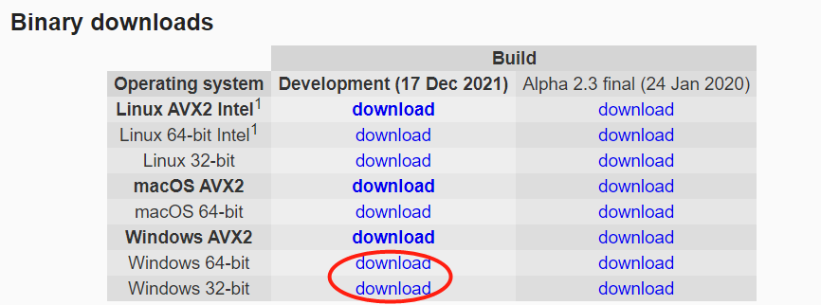

1000 Genomes Data
Download website：http://www.cog-genomics.org/plink/2.0/resources#1kg_phase3

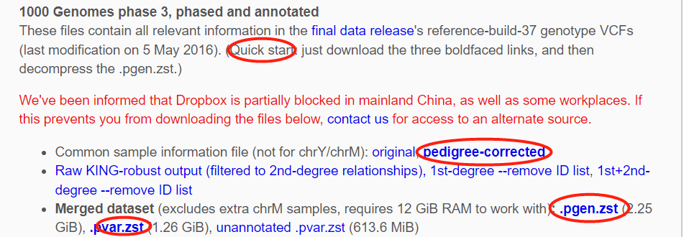

Decompression method

-Open cmd


-Change directory to plink2.exe

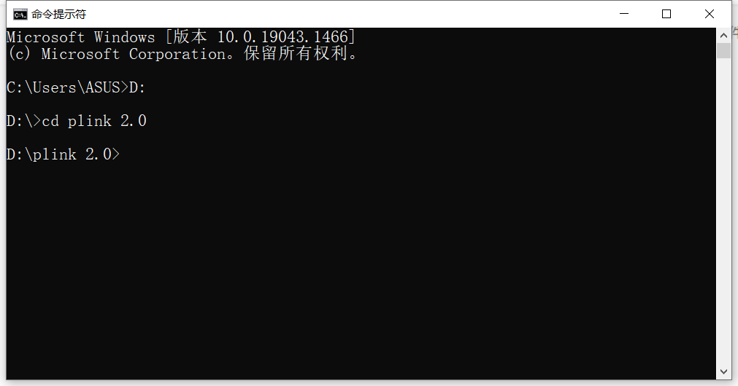

-Enter the code

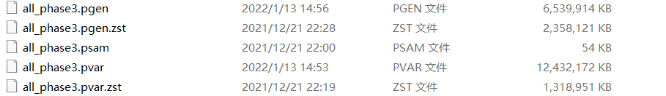

Use Plink 2.0 to extract the used data

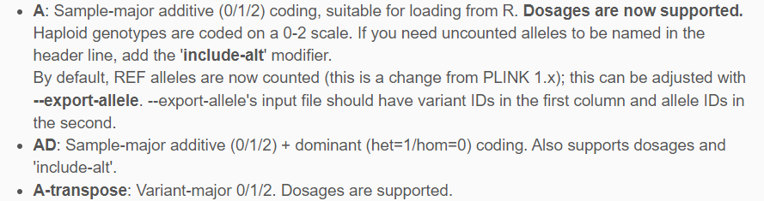

The output is as follows
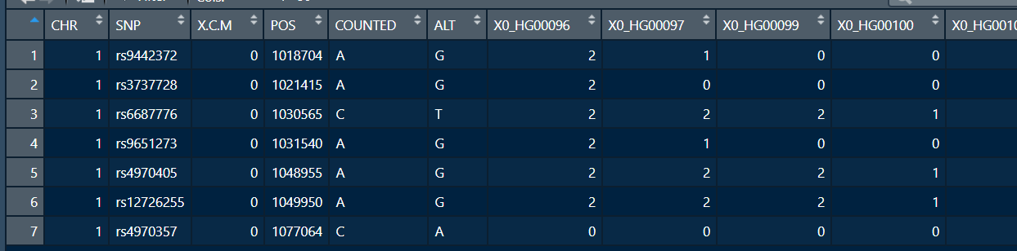

This can be further used for generate final_1kg_genotype_correct.Rdata
How to annotate SNPs based on genes

Download gene annotation data

Website：https://www.cog-genomics.org/plink/1.9/resources

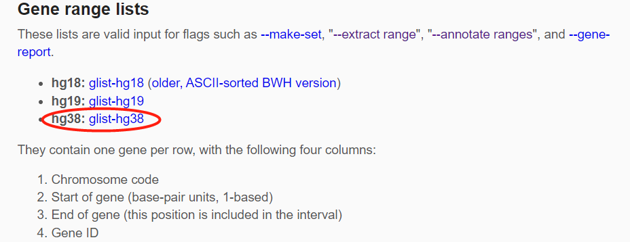

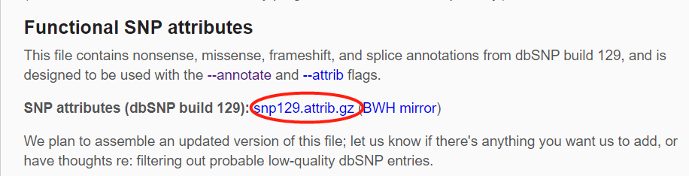

Open cmd and change the directory to plink 1.9，and enter the following:

plink 是指调用plink1.9软件

